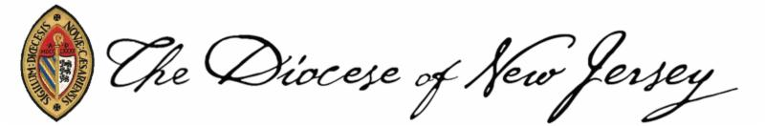

October 2022

To the Clergy and Congregations of the Diocese of New Jersey:

I would like to call to your attention the upcoming nominations for offices at the 2023 Diocesan Convention.

In accordance with Canon 5, Section 3 of the Constitutions and Canons of the Diocese of New Jersey, a list of the offices to be filled by the election of the 239th Diocesan Convention is provided. In addition, the Nomination Recommendation Form as well as a list of the Nominating Committee members will be available on the Diocesan website.

The Nominating Committee requests that the clergy and lay leadership of each of our churches review the lists of offices to be filled by election, publicize them to their congregations, and recommend candidates appropriate for those offices.

We continue to be very thankful for those who have served the Diocese ably and well in the past and may choose to serve again. We also welcome and encourage those who have not served before to consider serving in one or more of the open positions.

Please complete the Nomination Recommendation Form for persons whom you recommend or for yourself. Submit it to the address at the bottom of the form or complete it online here: http://www.formstack.com/forms/?408210-fFQ7hk5oRm by December 31, 2022. Please provide a statement of qualification in 75 words or less (or advise that this will be supplied by the nominee), as this statement is not provided by the committee. All names submitted are placed in the nomination process and subject to confirmation of eligibility. You can make copies of the nomination form. It is also available online at www.dioceseofnj.org. Please make this material known and available to your congregation.

Feel free to contact me or any member of the Nominating Committee with any questions or concerns.

Thank you for the opportunity to serve. We look forward to assisting you in whatever way possible for this very important part of our life in the Diocese of New Jersey.

Yours in Christ,
Paul
Canon Paul Ambos, Esq.
Secretary of Convention
Diocese of New Jersey
Electronically signed to expedite mailing

